Revision Log

Section: Fleet Portal / Delivery Issues

Edit #1: Populate Delivery issues with sample data
Client note: Please fill it up with issues.
Requested change: The Delivery issues page in the Fleet Portal ("What Darb has noticed about your drivers. Call the driver, sort it out, then say what you did.") currently shows an empty state — "Nothing outstanding. Good." — with a Show closed checkbox but no actual issue records. Populate it with sample delivery issues so the page (and the Show closed toggle) can be reviewed with real content, the same way other sections of the demo have representative data.
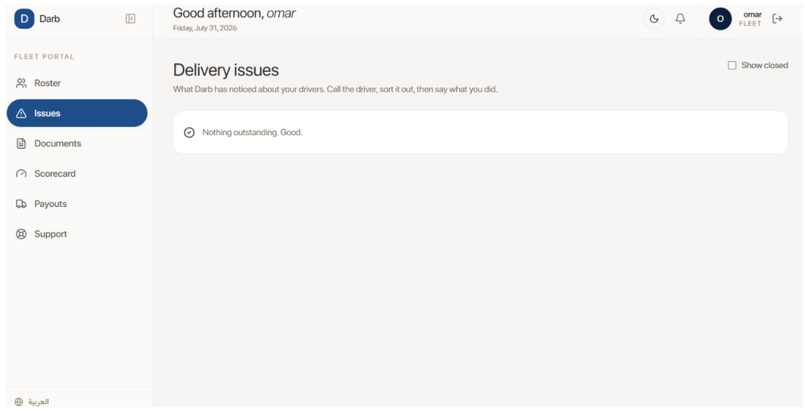
Fleet Portal — Delivery issues page, empty state with no sample data

Section: Fleet Portal / Roster

Edit #2: Add an import button on the Add document modal
Client note: For adding the document, there must be an import button.
Requested change: On the Add document panel (Document type dropdown — e.g. CIVIL ID, Expires date, Request a change), add a button to import/upload the actual document file, not just record its type and expiry date.
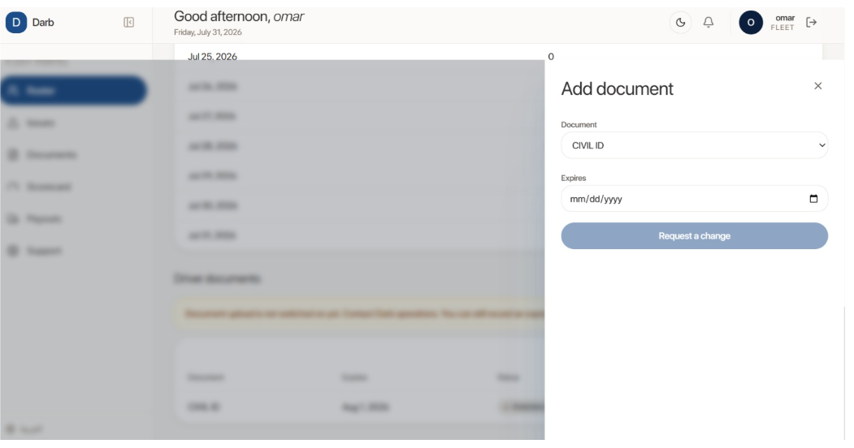
Add document panel — Document type and Expires fields, no import/upload button

Edit #3: Add roster summary counts and a Darb ID per driver
Client note: Must show up here the total number of drivers, and the total number for each category — car/bike — and the total number of drivers that are pending approval. Also must show the Darb ID for each driver.
Requested change: On the Driver roster page (Driver / Phone / Vehicle / Status / Today / 7 days / Rating / Document), add:
- Total number of drivers.
- A breakdown by vehicle category (Car / Bike).
- Total number pending approval (e.g. the "Pending Darb Review" status shown for driver "aziz").
- A Darb ID column, showing each driver's Darb-assigned ID.
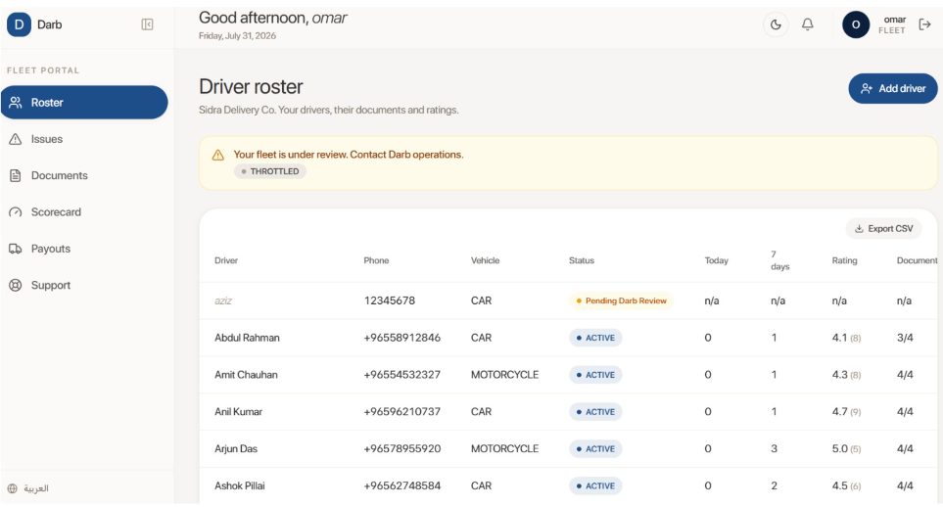
Driver roster — no summary counts (total/by category/pending) and no Darb ID column

Edit #4: Request leave needs a leave date and a return date
Client note: For the leave request, must specify a date for leaving and when he will join back.
Requested change: On the Request leave panel for a driver (e.g. Amit Chauhan — currently just a "Reason (optional)" text box and Request a change button), add two required date fields: the leave start date and the date he will return/join back.
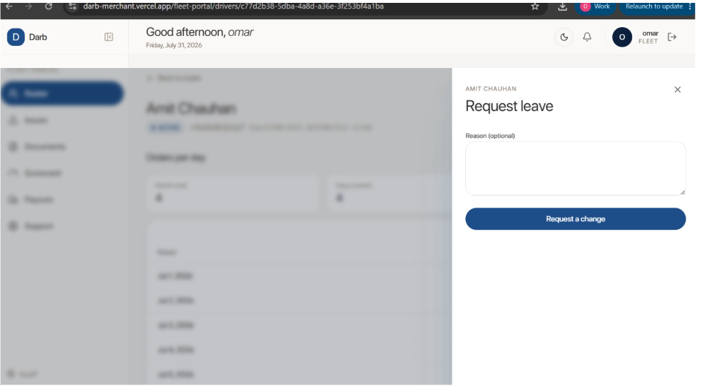
Request leave panel — Reason field only, no leave date or return date fields

Edit #5: Report resignation needs a last working date
Client note: For the resignation, must put a last working date.
Requested change: On the Report resignation panel for a driver (e.g. Amit Chauhan — currently just a "Reason (optional)" text box and Request a change button), add a required last working date field.
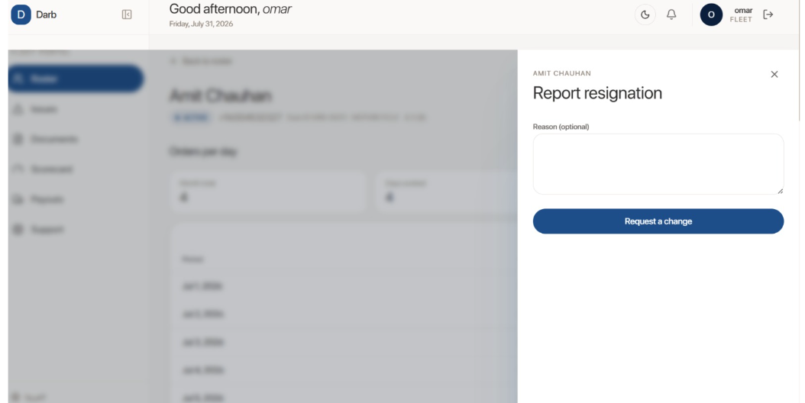
Report resignation panel — Reason field only, no last working date field

Section: Fleet Portal / Team

Edit #6: Add a Team tab, with delivery companies in the group instead of branches
Client note: Also one more thing, must have a Team tab, same as the Vendor concept — the "branches" will be other delivery companies in the same group.
Requested change: Add a Team tab to the Fleet Portal, following the same concept as the vendor portal's Team page (doc #9, Edit #7: users with Name / Email / Role / Access, scoped by branch). For the Fleet Portal, the branch-scoping concept becomes other delivery companies within the same group — i.e. a Fleet Owner can add team users and assign each one to specific delivery companies in their group, instead of vendor branches.

Section: Fleet Portal / Support

Edit #7: Rename the "Wallet" ticket type to "Payout" for Fleet
Client note: Change the Wallet to Payout.
Requested change: In the Fleet Portal's Support → New request ticket type dropdown (Technical / Order / Wallet / Other), rename Wallet to Payout, matching the Fleet Portal's own "Payouts" tab rather than the vendor-side "Wallet" terminology.
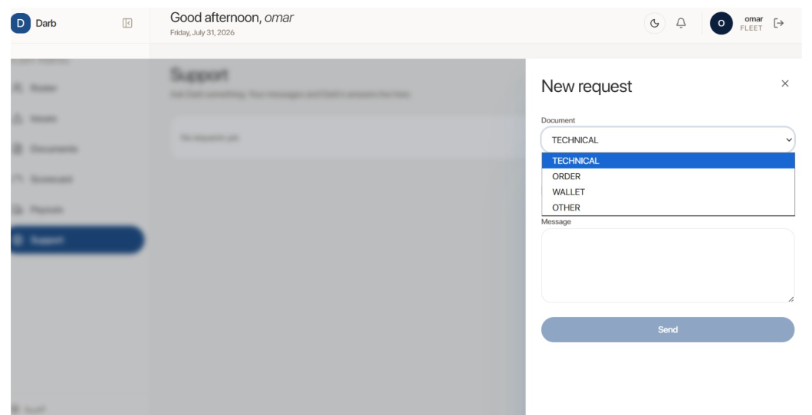
Fleet Support — New request ticket type dropdown, still labeled "Wallet" instead of "Payout"

Section: Fleet Portal / Payouts

Edit #8: Delivery company must confirm the payout before Darb processes it
Client note: Delivery company must confirm the payout before Darb processes it.
Requested change: On Payout statements (Period / Orders / Fee per order / Total / Status — e.g. June 2026 KD 194.700 FINAL, May 2026 KD 115.500 PAID), add a confirmation step: the delivery/fleet company must confirm a payout statement before Darb moves it from Final to processed/Paid, rather than Darb processing it unilaterally.
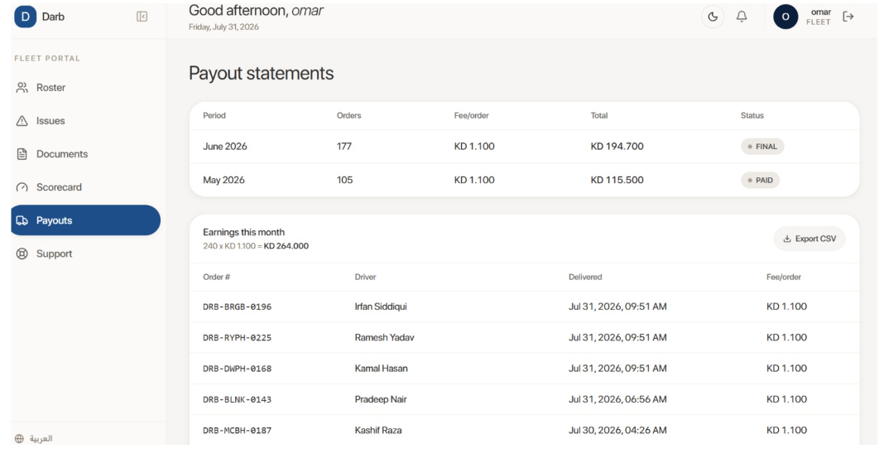
Payout statements — Final and Paid statuses, no confirmation step for the delivery company

